***Circuit Diagram***

**Control Unit Circuit:**

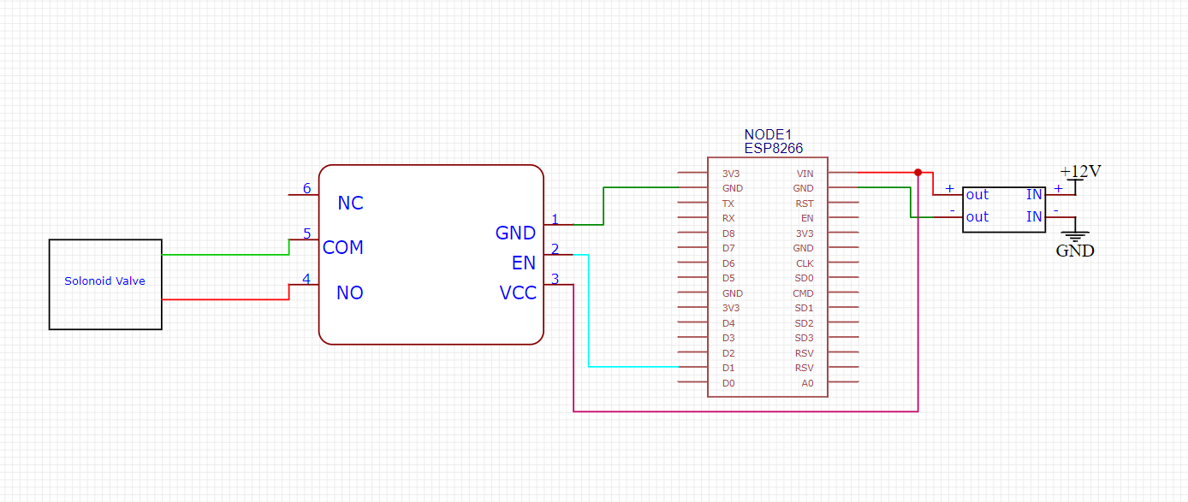

***Circuit Diagram***

**Sensor Unit Circuit:**

